# Exercise 9: React Component

Objectives and Outcomes

A React component is a reusable building block in React, a popular JavaScript library for building user interfaces. React components are the fundamental units of a React application and are responsible for encapsulating UI logic and rendering elements on the screen. By the end of this exercise, you should have a good understanding of React components and how to create and use them in your applications.

Exercises

1. Create a React component that displays your name and a brief message about yourself.

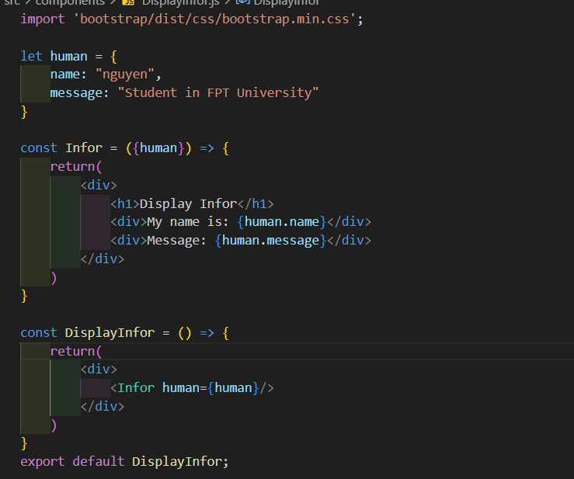



1. Create a simple React component that renders “Hello, World!”

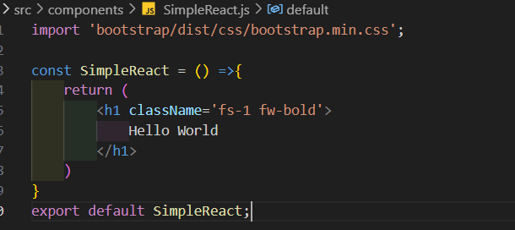



1. Build a counter application with buttons to increment and decrement the count.

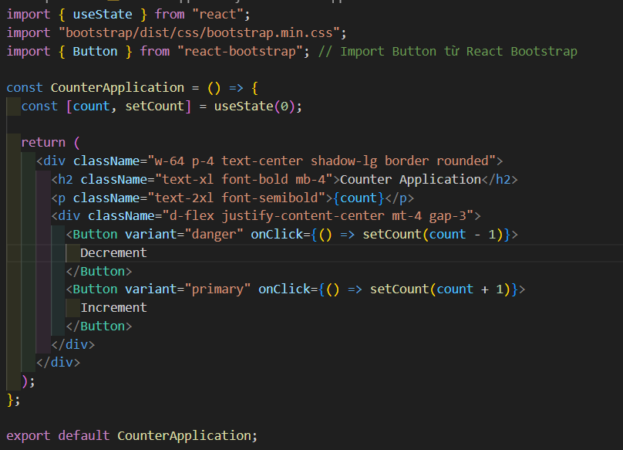

1. Create Simple Card

This is a common pattern seen around the web. Facebook messages, Tweets, and so on:



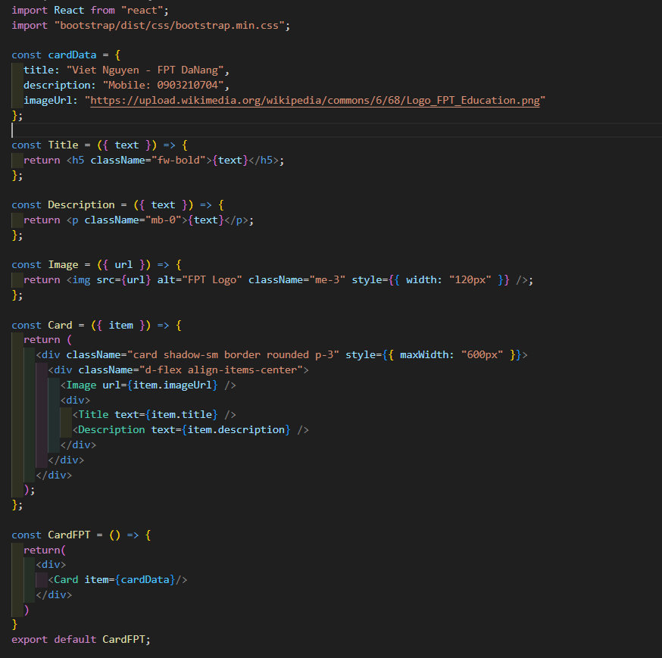

Start off with a simpler version:



Create a component for every rectangle, and figure out what props each one needs. It’s often easiest to start at the “leaf” nodes and work your way up – build the simplest, innermost elements first.

* Title - This is a simple text display. Takes as a prop the text to display.
* Description - Another simple text display. Takes as a prop the text to display.
* Image - A single image. Takes as a prop the url of the image.
* SimpleCard - the wrapper component. Takes item as a prop. item has a string title, a string description and a string imageUrl.

1. Create Simple Website

Header

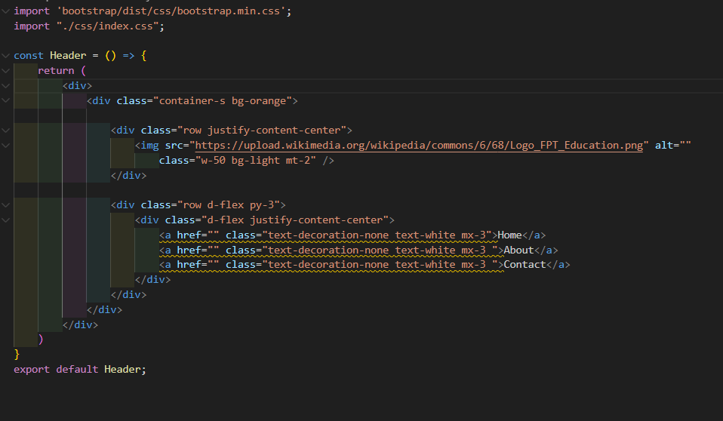



Body

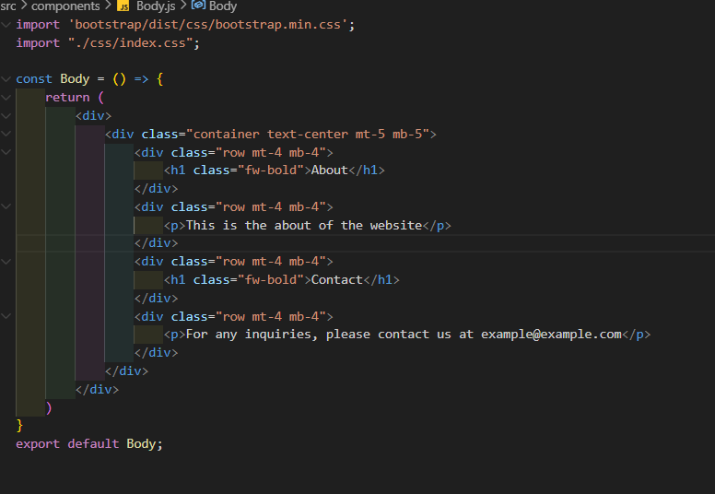



Footer

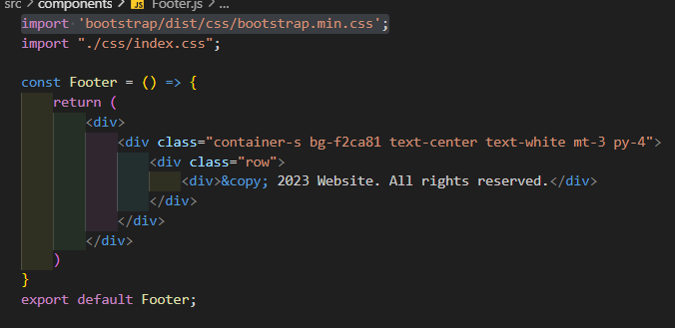





Conclusion

After learning about React components, you should now have a solid understanding of how to create and use them in your React applications.